Hi Ethan,

I went back through my notes and found the battery that we used in the earlier flight. Based on online searches, we selected the "Energizer Ultimate Lithium" battery. This is a "primary" (non-rechargeable) lithium battery that has good capacity and works down to -30 C (and colder, provided the current draw isn't too high). See: https://data.energizer.com/pdfs/l91.pdf

* Energizer Ultimate Lithium AA batteries are the world's longest lasting AA batteries
* Superior performance in extreme temperatures from -40 degrees F to 140 degrees F ensure reliable use in all seasons
* These double A batteries are leak proof batteries, guaranteed based on standard use
* AA battery 24 pack lasts up to 20 years in storage
* Use these double A batteries in high tech items, like digital cameras or game controllers, and household items such as smoke detectors, toys and games

1.5v constant discharge in 3000mah lithium cell

2.5/count 4.5V 6000mAH 1.5x3x2 6counts total：15.00

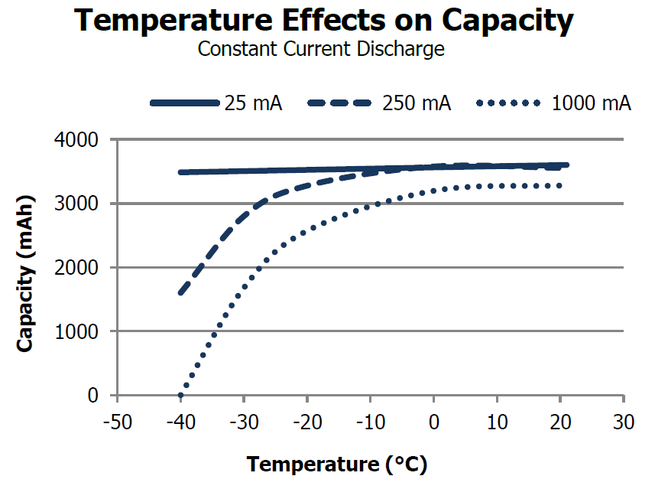

对比18650可充电锂电池



BENKIA I8650 Rechargeable Battery, 9900mah, high Capacity, 3.7V 18650B-4 Pack Rechargeable Battery is Suitable for Electronic Devices Such as Strong Light flashlights 22.99 3.7V 9900mAH total：6.00

I also came across a web site that advertises an inexpensive radio system. Please see: [https://kitsforhams.com/shari](https://kitsforhams.com/shari%20)  I am fairly sure that this system can also be used for APRS, but I will need to confirm that. By the way, the S/W that seems quite popular for APRS is something called Direwolf. <https://packet-radio.net/direwolf/>

* About SHARI <SHARI – Kits For Hams.pdf》

SHARI(SR-FRS1W Ham Allstar Radio Interface) is designed for construction and uses in the amateur radio service, works with a Pi2/Pi3 or Pi4, SHARI RF output power is 500 to 1000(default) milliwatts

$91.99 [Amazon](https://www.amazon.com/AURSINC-SHARI-PiHat-Compatible-420-450MHz/dp/B09DCY98N2/ref=sr_1_2?crid=1OM32MJ6K165V&keywords=AURSINC+Allstar&qid=1672866086&s=electronics&sprefix=aursinc+allstar%2Celectronics%2C281&sr=1-2&ufe=app_do%3Aamzn1.fos.006c50ae-5d4c-4777-9bc0-4513d670b6bc)

The UHF nodes are $5 less expensive than the VHF nodes.  Since Pi3B+ are slightly less expensive than Pi4Bs, I think our least expensive node using a SHARI would be a SHARI Pi3U (UHF, plugs into a Pi3).

<https://groups.io/g/SHARI>

A SHARI Pi3U kit is $60.  We can build the kit for you in which case the cost is $85.  You must provide the Raspberry Pi, a Pi case, a Pi power supply and a 4 GB or greater microSD card.  
If you have a radio with DIN connector packet interface, you can use a DINAH which is $35 for the kit and $45 assembled.  You still supply the Pi and accessories.

1. 为Raspberry Pi2, 3 or 4设计，不一定适合我们
2. 没有CPU、GPS、温度、气压，需要自行增加，总成本更高；
3. 集成度不如LightAPRS，总重量也会增加。

* About Direwolf

Dire Wolf is a software “soundcard” AX.25 packet modem/TNC and APRS encoder/decoder. It can be used stand-alone to observe APRS traffic, as a tracker, digipeater, APRStt gateway, or Internet Gateway (IGate) . In the early days of Amateur Packet Radio, it was necessary to use an expensive “Terminal Node Controller” (TNC) with specialized hardware. Those days are gone. You can now get better results at lower cost by connecting your radio to the “soundcard” interface of a computer and using software to decode the signals.

For the windows or Linux version please visite the following site.

<https://github.com/wb2osz/direwolf/releases>

这个软件可以在我们地面测试时，或者在放飞气球时，利用电台+PC+SW直接独立接收APRS数据保存和利用解码的GPS数据对气球进行追踪。

Finally, looked around and found that there is an amateur radio club in Redmond (see: http://radioredmond.com/radioredmond/home.aspx ). My guess is that they would be willing to help you. If you would like, I could write to them to see if they are interested. (Waiting a while before doing that is also an option.)

On Tuesday, when my technician returns to work, I will get details on the latest APRS/Cosmic watch design.

Best regards,

Dan Marlow